AIX Server and Informix DB Disaster Recovery

# Insight (ifx01) DRP procedure

Sunguard System Environment:

* Configuration ID: p690 Hotsite 2; LPAR11
* Hostname : ifx01
* OS level: 5300-08-01-0819
* CPU : 2
* Memory : 8G
* Internal Disk: 144G (4 x 36G)
* External Disk: 300G (6 x 50G)
* Network: 1 x 1000G
* DDS5 DAT72 Tape Drive: 1

Use HMC to connect to LPAR11 as a console.

Insight backup tapes:

* IFX01 system – April 29th + April 21st
* IFX01 App – May 2nd + May 3rd
* IFX01 DB – May 2nd + May 3rd

## Step 1: Restore the basic OS (rootvg) via OS backup tape

1. Display and/or change the primary boot device.

To display the primary boot device:

**# bootlist -m normal -o**

To change the primary boot device to tape drive:

**# bootlist -m normal rmt0**

1. Power off system by:

**# sync; sync; sync; shutdown -F**

.

1. Turning on the external devices first is necessary so that the system unit can identify them during the startup (boot) process. These include:

* Terminals
* Tape drives
* Monitors
* External disk drives

1. Power on the system. When booting, a screen will appear (before the one in Figure 1-1) asking you to press a function key (such as F1) to select the proper display as the system console. Each display on

the system will receive a function key number in order to identify it as the system console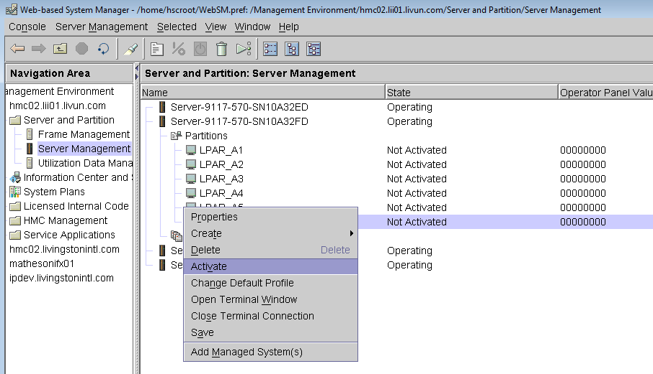

Active LPAR_A6, in Advaned… option, select Boot mode: SMS

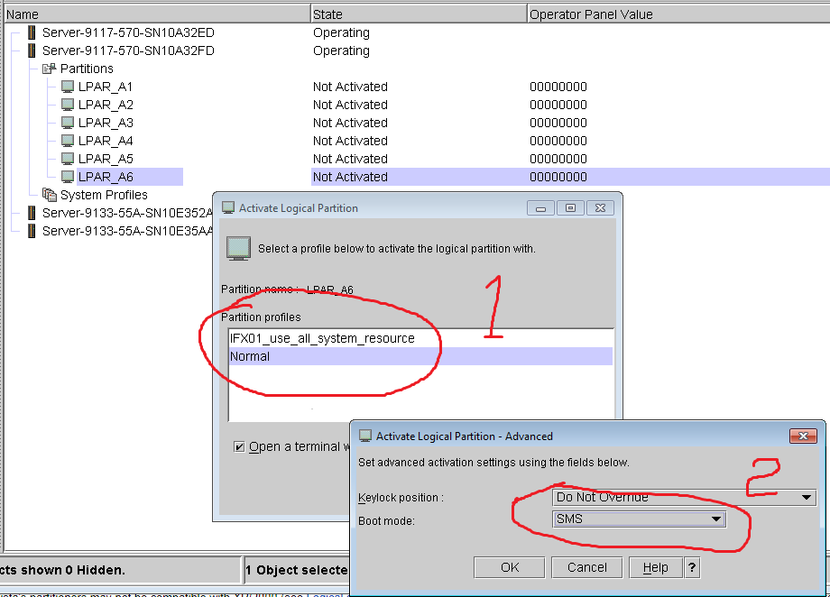

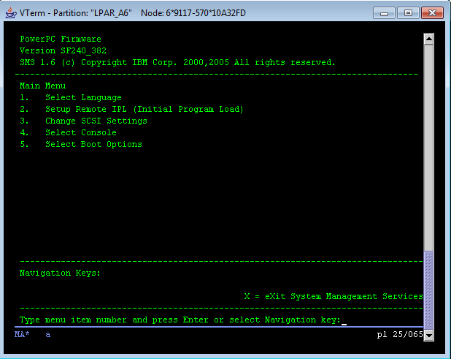

For SMS, we have 5 options for NVROM parameters setting, and or operation

1. Select Language, you should always choose English, or just leave it alone
2. Setup Remote IPL, it’s impotant to choose an enternet interface and set ip/routor to access NIM server
3. change scsi settings if you have lots of scsi cards connetions which may have scsi ID confliction
4. Select Console, always cureent one you work on
5. Select Boot Options

choose: 5 Select Boot options

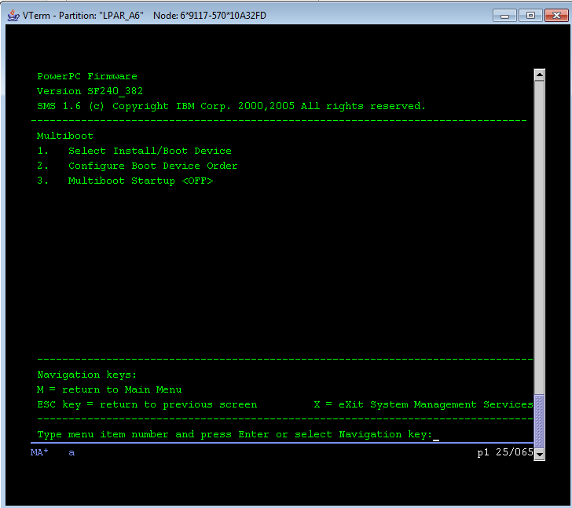

choose: 1 Select Install/Boot Device

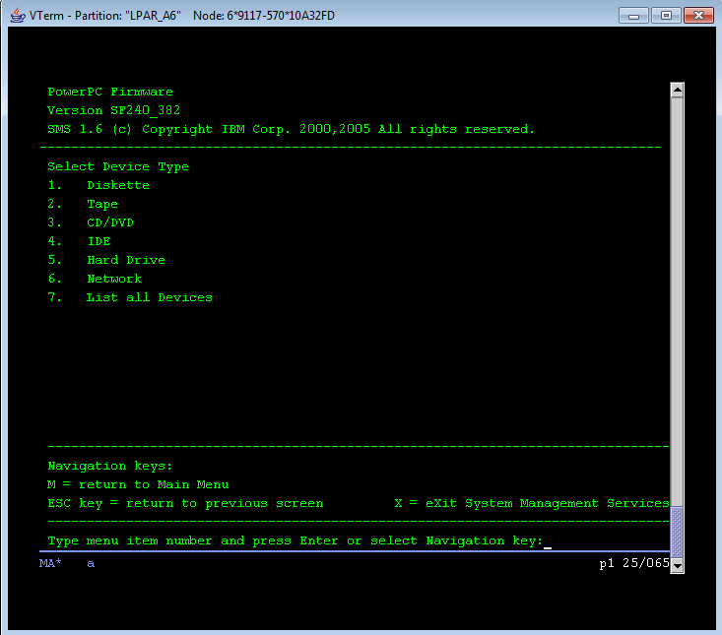

choose: 2 Tape

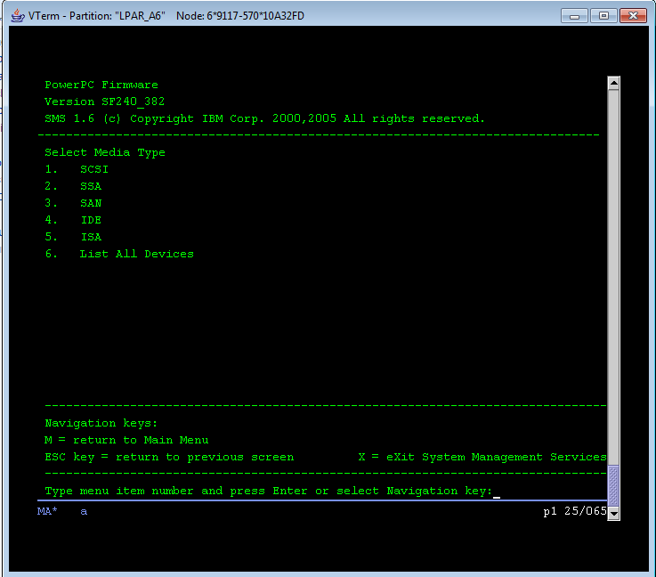

choose: 6 List All devices

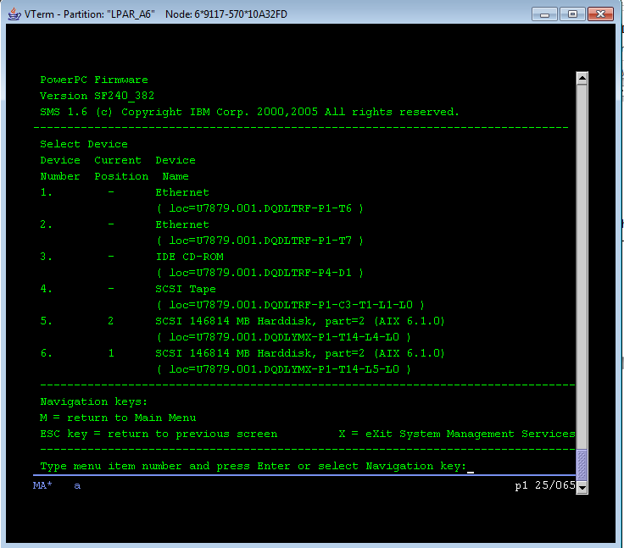

choose: 4 SCSI Tape

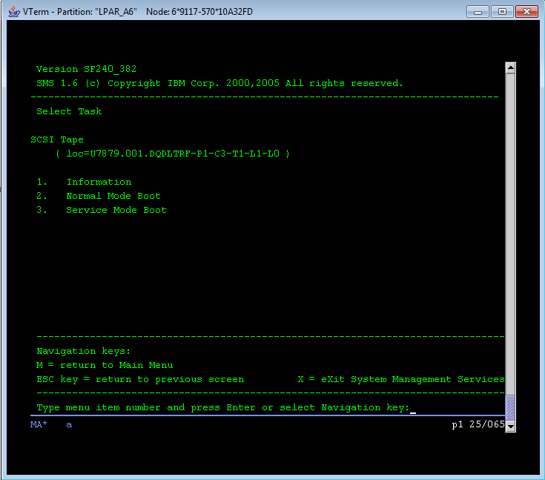

choos: 3 Sercei Mode Boot

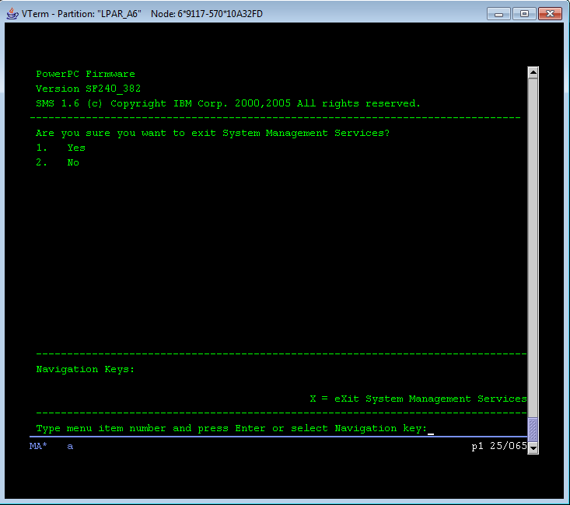

choose: 1 yes

-----------------------------------------------------------------------------------------------------------------------------

**TIPS:** If you need diagnose system hardware status right after you load the OS kernel from local hard disk,

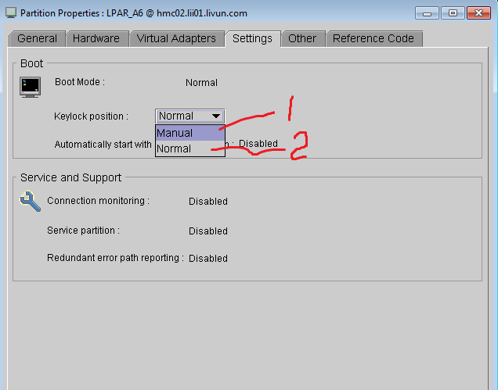

if choose 1, then

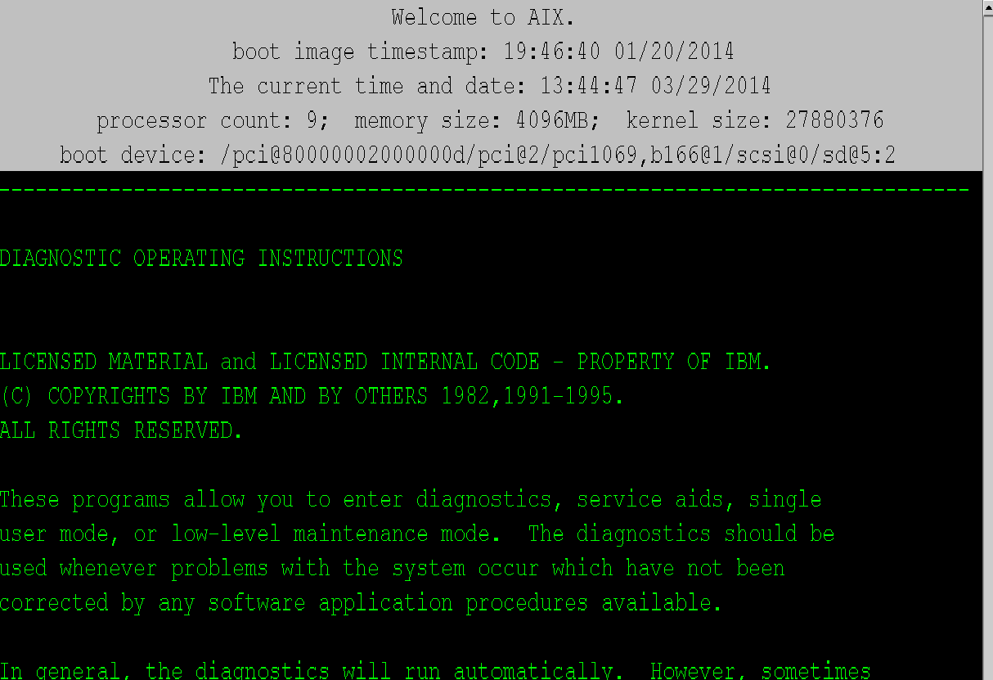

then,

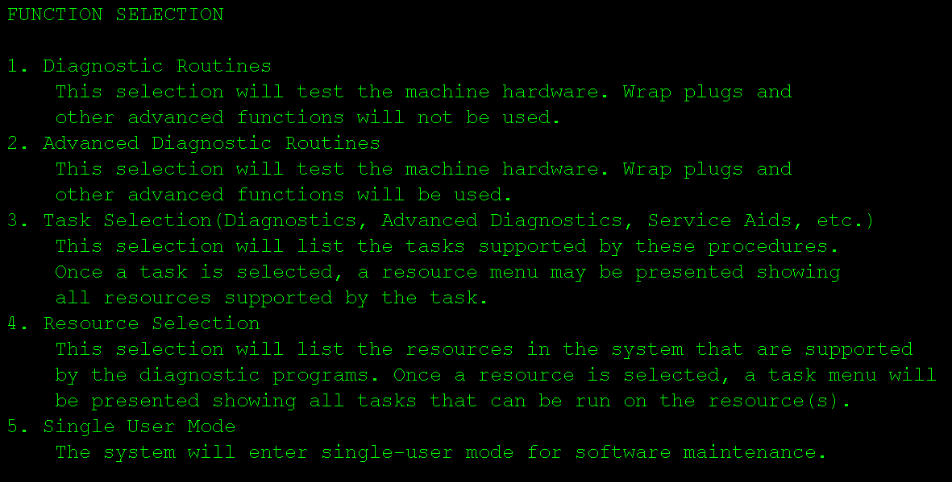

You choose 5, then init 2 to start the system OS to multiple user run level.

---------------------------------------------------------------------------------------------------------------------------

**TIPS: If Select boot/install from Network/DVD/Tape, which means load OS kernel Not from Hard Disk, you will face a situation that you may install a new OS,migrate OS, recover OS on to a selected Hard Disk,**

choose 3..Service Mode Boot, if you just want to load OS kernel in Service Mode, which configure Kernal by current system hardware, and enter a diagnose, maintenance for system recovery, totally new installation, and/or migration status

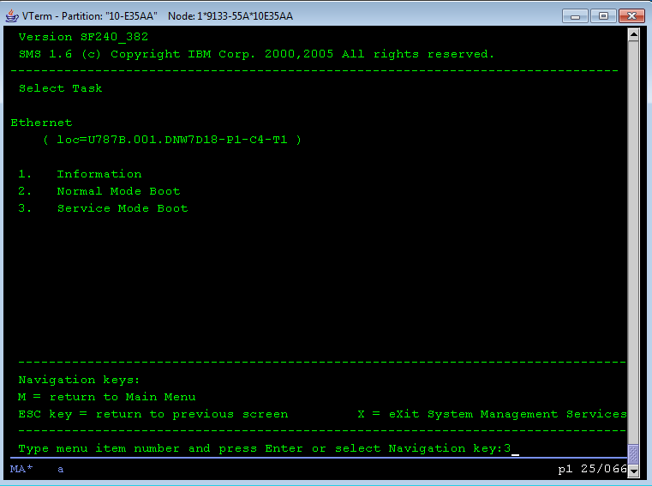

Then, choose 3,

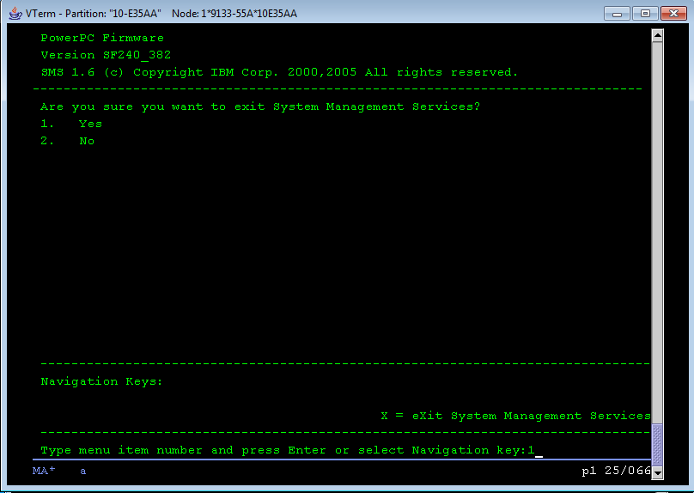

then, choose 1,

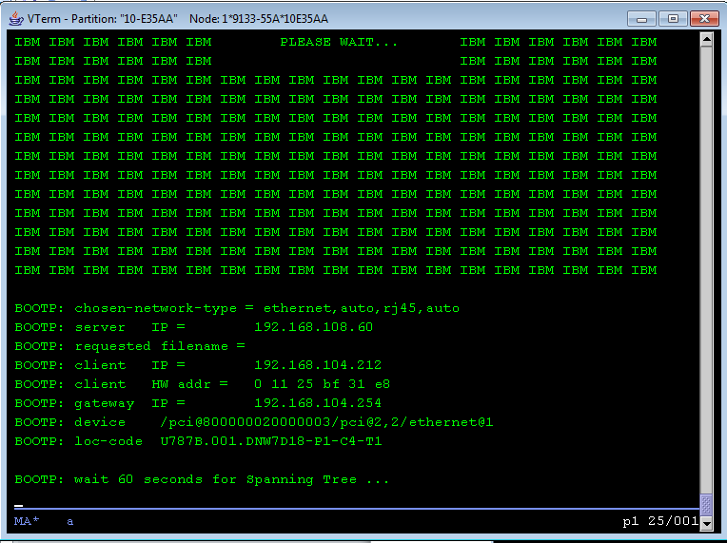

Loading the AIX Kernal….

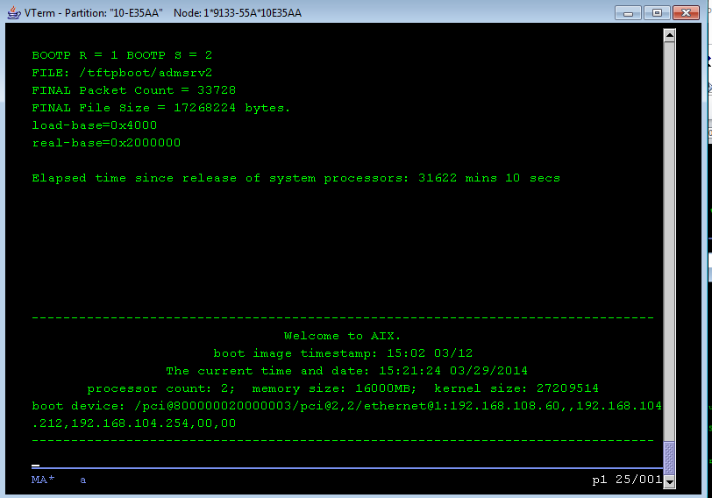

Following operation are controlled by OS kernel…

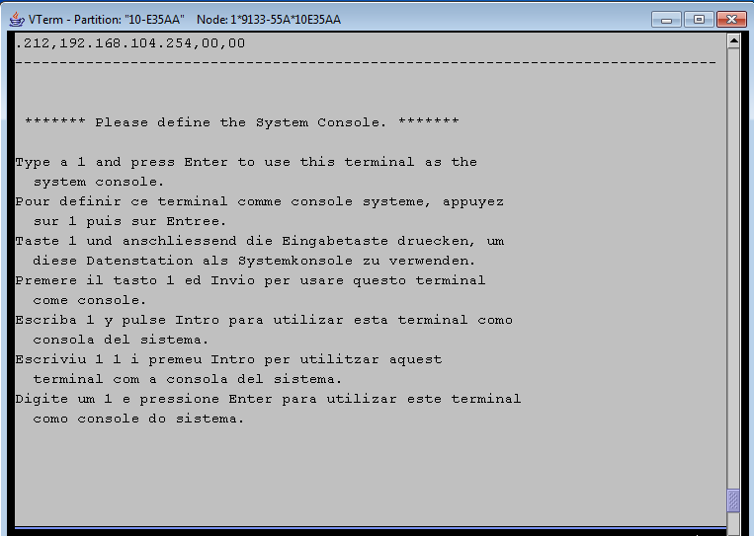

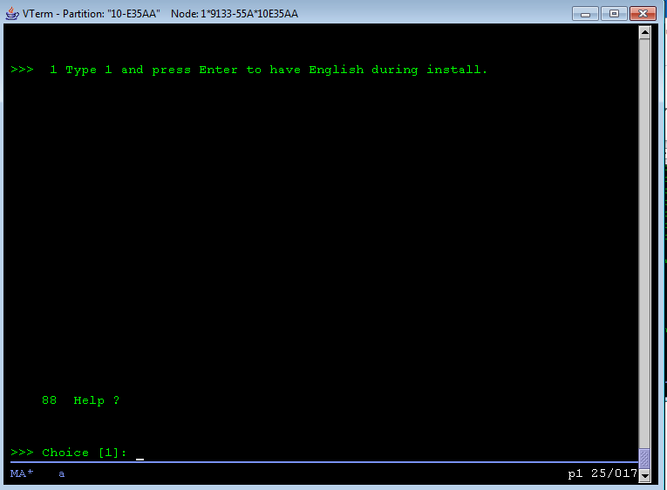

choose 1, have English during install

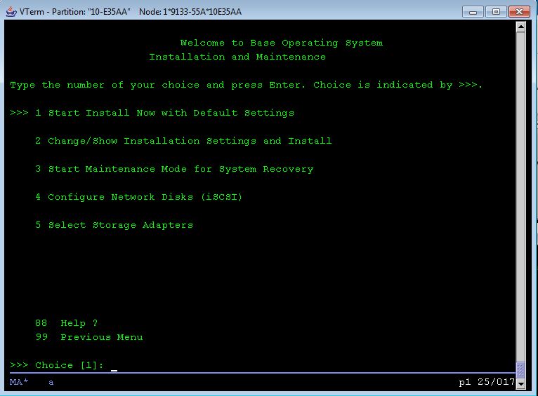

1. Start install Now with Dedault settings
2. Change/Show Installation Settings and install
3. Start maintenance Mode for System Recovery
4. Chfigure Network Disk (iscsi)
5. Select Storage Adapters

choose 3.. start maintenance Mode for System Recovery

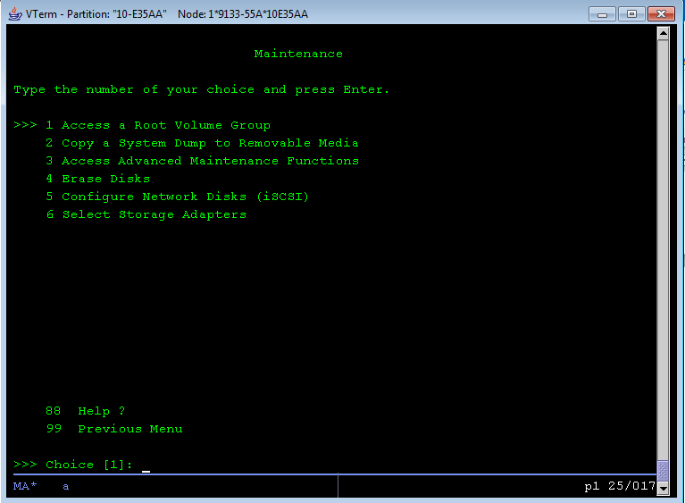

1. Access a Root Volume Group
2. Copy a system Dump to Removable Media
3. Access Advance Maintenace Functions
4. Erase Disks
5. Configure Network Disks (iscsi)
6. Select Storage Adapters

choose 3, Access Advance maintenance Functions

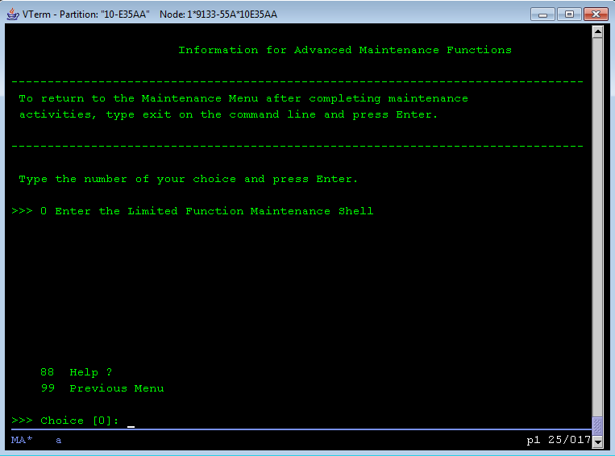

choose 1 Access root vg

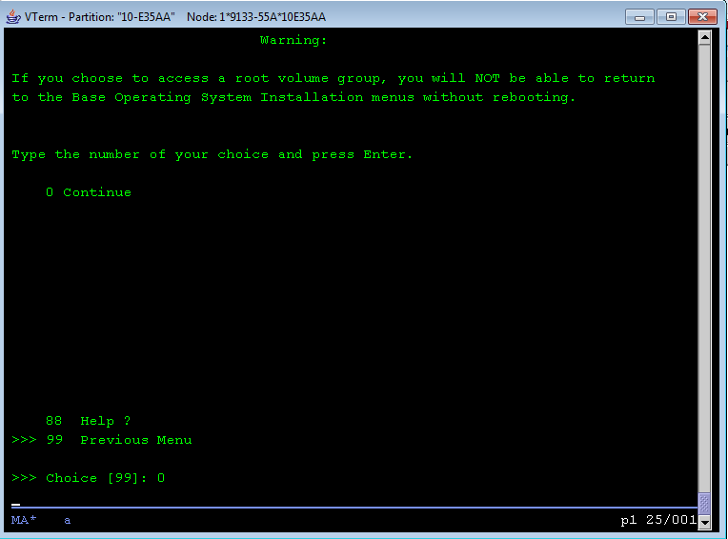

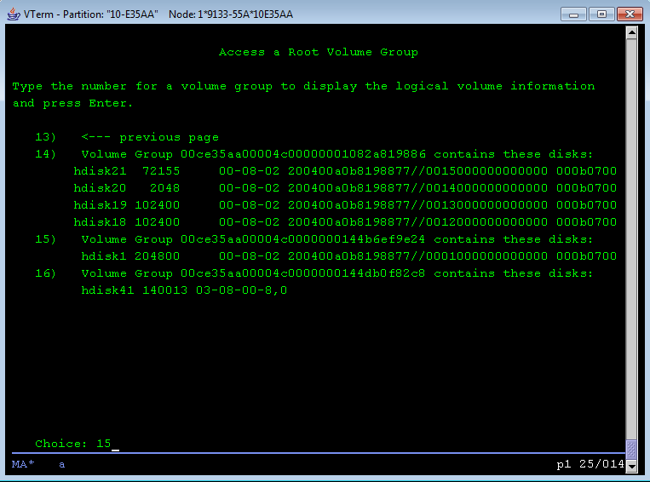

choose 15, Volume Group hdisk1

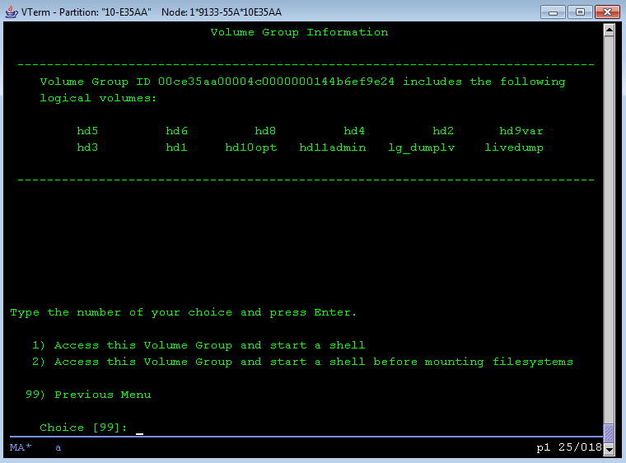

choose 1 Access this volume Group and start a shell, then you can fsck each filesystems on rootvg, and even change root password on /etc/passwd. or using #passwd directly.

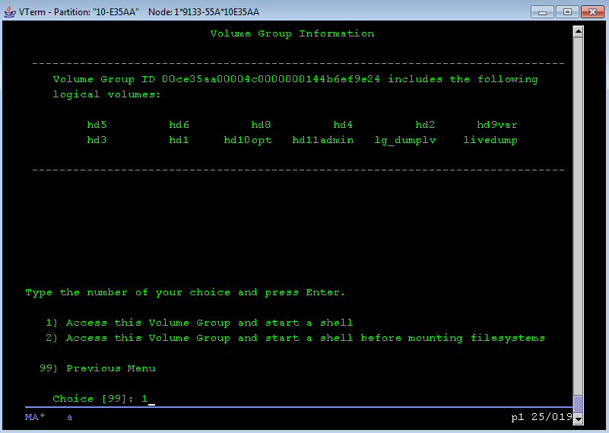

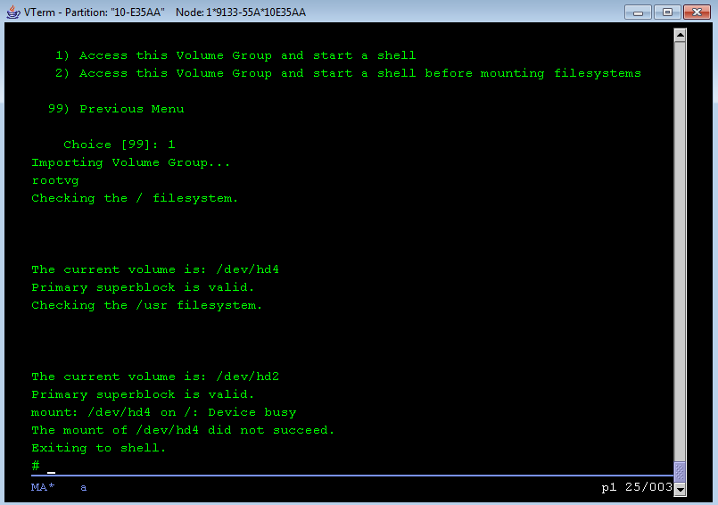

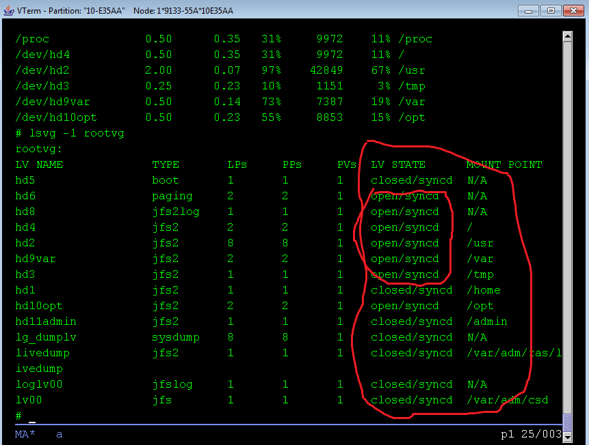

if choose 2 Importing Volume Group… rootvg, checking the / filesystem.

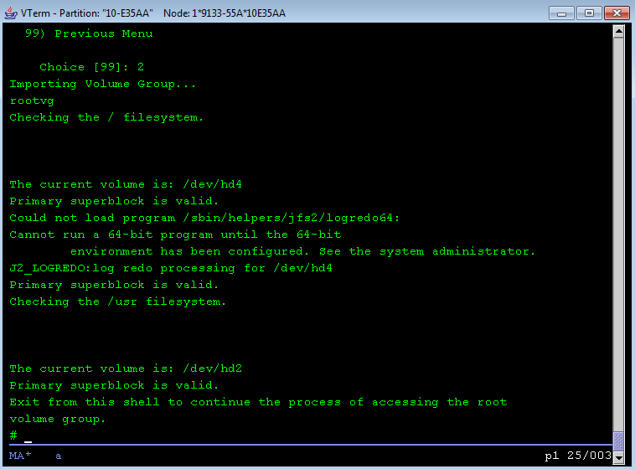

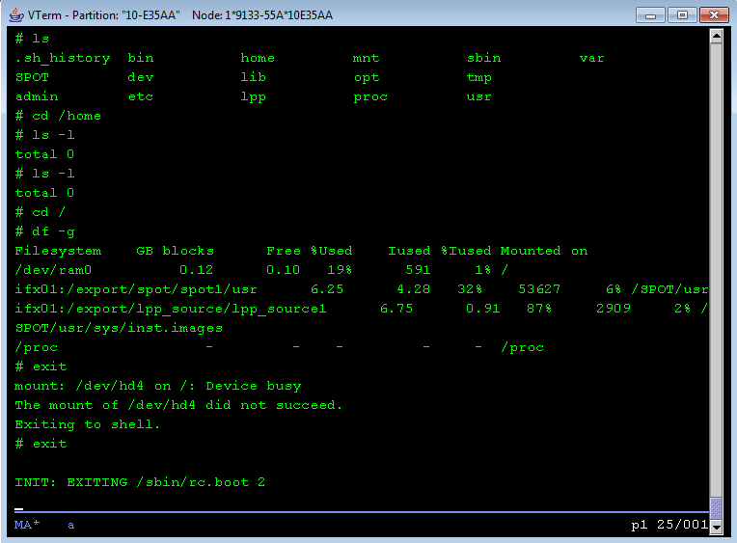

---------------------------------------------------------------------------------------------------------------------------

1. Insert mksysb OS backup tape media into the Tape Drive. The system begins booting from the installation media. After several minutes, c31 is displayed in the LED (if your system has an LED; A screen similar to the one in Figure 1-1 is displayed).



Figure 1-1

1. Select option 3, Start Maintenance Mode for System Recovery, and press Enter. A screen similar to the one in Figure 1-2 is shown.



Figure 1-2

If you want to change root passwd here using ” 1 Access a Root Volume Group”

1. Enter 5, Install from a system backup

Next System Backup Installation and Settings screen specifies disks where you want to install the backup image. The Change Disk(s) Where You Want to install screen displays. This screen lists all available disks on which you can install the system backup image. Three greater-than signs (>>>) mark each selected disk. Type the number and press Enter for each disk you choose. Type the number of a selected disk to deselect it. You can select more than one disk.

We can select all 4 internal disks (hdisk0 hdisk1 hdisk2 hdisk3) to create rootvg.

1. After you have finished selecting disks, press the Enter key.
2. Type 0 to accept the settings in the System Backup Installation and Settings screen. The Installing Base Operating System screen displays the rate of completion and duration.

After OS restored from backup tape, the OS should be boot in normal mode.

## Step 2: Setup System file systems environment for Application restoration

1. Preparation in /etc/filesystems:

**# cp /etc/filesystems /etc/filesystems.backup.20120503**

Remove stanza entries of following filesystems in /etc/filesystems:

/ix_root

/ix_plog

/ix_llog

/ix_dat1

/ix_dat2

/ix_dat3

/ix_idx1

/ix_idx2

/ix_idx3

/ix_temp

/usr/apps

/netins

/dmqjtmp

/recyclebox

/ach_root

/ach_plog

/ach_llog

/ach_dat1

/ach_dat2

/ach_idx1

/ach_idx2

/ach_temp

**# vi /etc/filesystems**

1. Use 6 external disks (300G) to create application and database storage space:

# Create Volume Group dbvg

/usr/sbin/mkvg -s 256 -f -y dbvg hdisk4 hdisk5 hdisk6 hdisk7 hdisk8 hdisk9

# Create Logic Volumes

/usr/sbin/mklv -t jfs2log -y loglv00 dbvg 1

/usr/sbin/mklv -t jfs2 -y ixrootlv dbvg 1

/usr/sbin/mklv -t jfs2 -y ixploglv dbvg 1

/usr/sbin/mklv -t jfs2 -y ixlloglv dbvg 4

/usr/sbin/mklv -t jfs2 -y ixdat1lv dbvg 88

/usr/sbin/mklv -t jfs2 -y ixdat2lv dbvg 100

/usr/sbin/mklv -t jfs2 -y ixdat3lv dbvg 76

/usr/sbin/mklv -t jfs2 -y ixidx1lv dbvg 28

/usr/sbin/mklv -t jfs2 -y ixidx2lv dbvg 20

/usr/sbin/mklv -t jfs2 -y ixidx3lv dbvg 16

/usr/sbin/mklv -t jfs2 -y ixtemplv dbvg 16

/usr/sbin/mklv -t jfs2 -y appslv dbvg 40

/usr/sbin/mklv -t jfs2 -y netinslv dbvg 10

/usr/sbin/mklv -t jfs2 -y dmqjtmplv dbvg 50

/usr/sbin/mklv -t jfs2 -y recyclelv dbvg 40

/usr/sbin/mklv -t jfs2 -y achrootlv dbvg 1

/usr/sbin/mklv -t jfs2 -y achploglv dbvg 1

/usr/sbin/mklv -t jfs2 -y achlloglv dbvg 4

/usr/sbin/mklv -t jfs2 -y achdat1lv dbvg 152

/usr/sbin/mklv -t jfs2 -y achdat2lv dbvg 164

/usr/sbin/mklv -t jfs2 -y achidx1lv dbvg 12

/usr/sbin/mklv -t jfs2 -y achidx2lv dbvg 12

/usr/sbin/mklv -t jfs2 -y achtemplv dbvg 8

# Create FileSystems

/usr/sbin/crfs -v jfs2 -d ixrootlv -m /ix_root -A yes -p rw -a logname=loglv00

/usr/sbin/crfs -v jfs2 -d ixploglv -m /ix_plog -A yes -p rw -a logname=loglv00

/usr/sbin/crfs -v jfs2 -d ixlloglv -m /ix_llog -A yes -p rw -a logname=loglv00

/usr/sbin/crfs -v jfs2 -d ixdat1lv -m /ix_dat1 -A yes -p rw -a logname=loglv00

/usr/sbin/crfs -v jfs2 -d ixdat2lv -m /ix_dat2 -A yes -p rw -a logname=loglv00

/usr/sbin/crfs -v jfs2 -d ixdat3lv -m /ix_dat3 -A yes -p rw -a logname=loglv00

/usr/sbin/crfs -v jfs2 -d ixidx1lv -m /ix_idx1 -A yes -p rw -a logname=loglv00

/usr/sbin/crfs -v jfs2 -d ixidx2lv -m /ix_idx2 -A yes -p rw -a logname=loglv00

/usr/sbin/crfs -v jfs2 -d ixidx3lv -m /ix_idx3 -A yes -p rw -a logname=loglv00

/usr/sbin/crfs -v jfs2 -d ixtemplv -m /ix_temp -A yes -p rw -a logname=loglv00

/usr/sbin/crfs -v jfs2 -d appslv -m /usr/apps -A yes -p rw -a logname=loglv00

/usr/sbin/crfs -v jfs2 -d netinslv -m /netins -A yes -p rw -a logname=loglv00

/usr/sbin/crfs -v jfs2 -d dmqjtmplv -m /dmqjtmp -A yes -p rw -a logname=loglv00

/usr/sbin/crfs -v jfs2 -d recyclelv -m /recyclebox -A yes -p rw -a logname=loglv00

/usr/sbin/crfs -v jfs2 -d achrootlv -m /ach_root -A yes -p rw -a logname=loglv00

/usr/sbin/crfs -v jfs2 -d achploglv -m /ach_plog -A yes -p rw -a logname=loglv00

/usr/sbin/crfs -v jfs2 -d achlloglv -m /ach_llog -A yes -p rw -a logname=loglv00

/usr/sbin/crfs -v jfs2 -d achdat1lv -m /ach_dat1 -A yes -p rw -a logname=loglv00

/usr/sbin/crfs -v jfs2 -d achdat2lv -m /ach_dat2 -A yes -p rw -a logname=loglv00

/usr/sbin/crfs -v jfs2 -d achidx1lv -m /ach_idx1 -A yes -p rw -a logname=loglv00

/usr/sbin/crfs -v jfs2 -d achidx2lv -m /ach_idx2 -A yes -p rw -a logname=loglv00

/usr/sbin/crfs -v jfs2 -d achtemplv -m /ach_temp -A yes -p rw -a logname=loglv00

# Mount all these filesystems

/usr/sbin/mount all

## Step 3: Restore Application

To restore the backups from a single-volume, multiple-backup tape, for example:

**# restore -xvqs 5 –f /dev/rmt0.1**

**# restore -xvqs 4 –f /dev/rmt0.1**

The first command extracts all files from the fifth archive on the multiple-backup tape specified by /dev/rmt0.1. The .1 designator specifies the tape device will not be retensioned when it is opened and that it will not be rewound when it is closed. It is necessary to use a no-rewind-on-close, no-retension-on-open tape device because of the behavior of the -s flag. The second command extracts all the files from the fourth archive (relative to the current location of the tape head on the tape). After the fifth archive has been restored, the tape read/write head is in a position to read the archive. Since you want to extract the ninth archive on the tape, you must specify a value of 4 with the -s flag. This is because the -s flag is relative to your position on the tape and not to an archives position on the tape. The ninth archive is the fourth archive from your current position on the tape.

The Application file systems backup sequence:

filesystem: / File Archive number: 1

filesystem: /home File Archive number: 2

filesystem: /usr File Archive number: 3

filesystem: /var File Archive number: 4

filesystem: /tmp File Archive number: 5

filesystem: /opt File Archive number: 6

filesystem: /ibm File Archive number: 7

filesystem: /netins File Archive number: 8

filesystem: /dmqjtmp File Archive number: 9

filesystem: /recyclebox File Archive number: 10

filesystem: /usr/apps File Archive number: 11

filesystem: /insight File Archive number: 12

filesystem: /var/adm/ras/livedump File Archive number: 13

filesystem: /admin File Archive number: 14

We need to restore file systems**: /ibm; /netins; /dmqjtmp; /recyclebox; /usr/apps**; The other file systems are restored by OS restore process (They are in rootvg).

1. Insert APP backup tape media into the Tape Drive.

**# tctl –f /dev/rmt0 rewind**

1. To restore /ibm file system, Change to a directory that will be used to restore the files

**# cd /ibm**

**# restore -xvqs 7 –f /dev/rmt0.1**

You have not read any media yet.

Unless you know which volume your file or files are on, you should start with the last volume and work towards the first volume.

Specify the next volume number: **1**

**[** Type the volume number and press Return. If you have only one volume, type 1 and press Return ]

Do you want to set the owner or the mode for the current directory? [ yes or no ] **no**

[ To keep the mode of the current directory unchanged, enter **no** at the set owner/mode prompt ]

1. Then, to restore /netins file system:

**# cd /netins**

**# restore -xvqs 1 –f /dev/rmt0.1**

You have not read any media yet.

Unless you know which volume your file or files are on, you should start with the last volume and work towards the first volume.

Specify the next volume number: **1**

Do you want to set the owner or the mode for the current directory? [ yes or no ] **no**

1. Then, to restore /dmqjtmp file system:

**# cd /dmqjtmp**

**# restore -xvqs 1 –f /dev/rmt0.1**

You have not read any media yet.

Unless you know which volume your file or files are on, you should start with the last volume and work towards the first volume.

Specify the next volume number: **1**

Do you want to set the owner or the mode for the current directory? [ yes or no ] **yes**

1. Then, to restore /recyclebox file system:

**# cd /recyclebox**

**# restore -xvqs 1 –f /dev/rmt0.1**

You have not read any media yet.

Unless you know which volume your file or files are on, you should start with the last volume and work towards the first volume.

Specify the next volume number: **1**

Do you want to set the owner or the mode for the current directory? [ yes or no ] **yes**

1. Then, to restore /usr/apps file system:

**# cd /usr/apps**

**# restore -xvqs 1 –f /dev/rmt0.1**

You have not read any media yet.

Unless you know which volume your file or files are on, you should start with the last volume and work towards the first volume.

Specify the next volume number: **1**

Do you want to set the owner or the mode for the current directory? [ yes or no ] **yes**

1. Eject the tape from tape drive:

**# tctl –f /dev/rmt0.1 offline**

## Step 4: Setup Informix database Restore Environment

# Create Database Storage files (chunks) for informix dbspace

cd /ix_dat1

/usr/bin/touch ix_dat1.1

/usr/bin/touch ix_dat1.10

/usr/bin/touch ix_dat1.11

/usr/bin/touch ix_dat1.12

/usr/bin/touch ix_dat1.13

/usr/bin/touch ix_dat1.14

/usr/bin/touch ix_dat1.15

/usr/bin/touch ix_dat1.16

/usr/bin/touch ix_dat1.17

/usr/bin/touch ix_dat1.18

/usr/bin/touch ix_dat1.19

/usr/bin/touch ix_dat1.2

/usr/bin/touch ix_dat1.20

/usr/bin/touch ix_dat1.21

/usr/bin/touch ix_dat1.22

/usr/bin/touch ix_dat1.3

/usr/bin/touch ix_dat1.4

/usr/bin/touch ix_dat1.5

/usr/bin/touch ix_dat1.6

/usr/bin/touch ix_dat1.7

/usr/bin/touch ix_dat1.8

/usr/bin/touch ix_dat1.9

cd /ix_dat2

/usr/bin/touch ix_dat2.1

/usr/bin/touch ix_dat2.10

/usr/bin/touch ix_dat2.11

/usr/bin/touch ix_dat2.12

/usr/bin/touch ix_dat2.13

/usr/bin/touch ix_dat2.14

/usr/bin/touch ix_dat2.15

/usr/bin/touch ix_dat2.16

/usr/bin/touch ix_dat2.17

/usr/bin/touch ix_dat2.18

/usr/bin/touch ix_dat2.19

/usr/bin/touch ix_dat2.2

/usr/bin/touch ix_dat2.20

/usr/bin/touch ix_dat2.21

/usr/bin/touch ix_dat2.22

/usr/bin/touch ix_dat2.23

/usr/bin/touch ix_dat2.24

/usr/bin/touch ix_dat2.25

/usr/bin/touch ix_dat2.3

/usr/bin/touch ix_dat2.4

/usr/bin/touch ix_dat2.5

/usr/bin/touch ix_dat2.6

/usr/bin/touch ix_dat2.7

/usr/bin/touch ix_dat2.8

/usr/bin/touch ix_dat2.9

cd /ix_dat3

/usr/bin/touch ix_dat3.1

/usr/bin/touch ix_dat3.10

/usr/bin/touch ix_dat3.11

/usr/bin/touch ix_dat3.12

/usr/bin/touch ix_dat3.13

/usr/bin/touch ix_dat3.14

/usr/bin/touch ix_dat3.15

/usr/bin/touch ix_dat3.16

/usr/bin/touch ix_dat3.17

/usr/bin/touch ix_dat3.18

/usr/bin/touch ix_dat3.19

/usr/bin/touch ix_dat3.2

/usr/bin/touch ix_dat3.3

/usr/bin/touch ix_dat3.4

/usr/bin/touch ix_dat3.5

/usr/bin/touch ix_dat3.6

/usr/bin/touch ix_dat3.7

/usr/bin/touch ix_dat3.8

/usr/bin/touch ix_dat3.9

cd /ix_idx1

/usr/bin/touch ix_idx1.1

/usr/bin/touch ix_idx1.2

/usr/bin/touch ix_idx1.3

/usr/bin/touch ix_idx1.4

/usr/bin/touch ix_idx1.5

/usr/bin/touch ix_idx1.6

/usr/bin/touch ix_idx1.7

cd /ix_idx2

total 0

/usr/bin/touch ix_idx2.1

/usr/bin/touch ix_idx2.2

/usr/bin/touch ix_idx2.3

/usr/bin/touch ix_idx2.4

/usr/bin/touch ix_idx2.5

cd /ix_idx3

/usr/bin/touch ix_idx3.1

/usr/bin/touch ix_idx3.2

/usr/bin/touch ix_idx3.3

/usr/bin/touch ix_idx3.4

cd /ix_llog

/usr/bin/touch ix_llog.1

cd /ix_plog

/usr/bin/touch ix_plog.1

cd /ix_root:

/usr/bin/touch ix_root.1

cd /ix_temp

/usr/bin/touch ix_temp.1

/usr/bin/touch ix_temp.2

/usr/bin/touch ix_temp.3

/usr/bin/touch ix_temp.4

cd /

/usr/bin/chown -R informix:informix ix*

/usr/bin/chmod –R 660 ix*

/usr/bin/chmod 777 ix*

Reboot the system

**# sync; sync; sync; shutdown -Fr**

## Step 5: Restore Informix database

1. Setup Informix running environment:

Login as root

**# hostname ifx01**

**# ifconfig en0 192.168.108.60**

login as USER Informix

**$ . ./ids115.env ipdb**

1. Restore Informix Database:

Insert Informix ‘ontape -s’ backup tape media into the Tape Drive

**$ ontape –r**

Please mount tape 1 on /dev/rmt0 and press Return to continue:…

[enter]

Continue to restore? (y/n) y

Do you want to back up the logs? (y/n) n

Warning : If you intent to use J/Foundation or GLS for Unicode feature(GLU) with this server instance, please make sure that your SHMBASE value specifies in onconfig is 0x40000000L or above. Otherwise you will have problems while attaching or dynamically adding virtul shared memory segments. Please refer to Server machine notes for more information.

Restore a level 1 archive (y/n) n

Do you want to restore log tapes? (y/n) n

/usr/apps/inf/ver115UC3/bin/onmode –sy

Program over

1. Bring the database server online when the restore is over

**$ onmode -m**

## Step 6: Bring Database and application online

Run Informix:

**login as USER Informix**

**$ . ./ids115.env ipdb**

**$ oninit**

Shutdown Informix:

**$ onmode –ky**

Run Tuxedo Application:

**login as ipgown**

**$ cd /usr/apps/ipg/ver001/srv/locus**

**$ . ./setenv.locus**

**$ tmboot –y**

Shutdown Tuxedo Application:

**# tmshutdown -y**

## For Archive database server ardb DRP consideration

Archive database storage architecture:

IBM Informix Dynamic Server Version 11.50.UC3W2 -- On-Line -- Up 02:24:07 -- 929856 Kbytes

Dbspaces

address number flags fchunk nchunks pgsize flags owner name

50431810 1 0x1 1 1 4096 N informix rootdbs

5051dd50 2 0x1 2 1 4096 N informix llogdbs

5051deb0 3 0x1 3 2 4096 N informix tempdbs1

5138a018 4 0x1 4 1 4096 N informix plogdbs

5138a178 5 0x1 5 44 4096 N informix datadbs1

5138a2d8 6 0x1 27 48 4096 N informix datadbs2

5138a438 7 0x1 51 3 4096 N informix indxdbs1

5138a598 8 0x1 54 3 4096 N informix indxdbs2

8 active, 2047 maximum

Chunks

address chunk/dbs offset size free bpages flags pathname

50431970 1 1 0 62500 54561 PO-- /ach_root/ach_root.1

5138a6f8 2 2 0 250000 124947 PO-- /ach_llog/ach_llog.1

5138a8c8 3 3 0 250000 249547 PO-- /ach_temp/ach_temp.1

5138aa98 4 4 0 62500 2447 PO-- /ach_plog/ach_plog.1

5138ac68 5 5 0 250000 0 PO-- /ach_dat1/ach_dat1.1

5138ae38 6 5 0 250000 3 PO-- /ach_dat1/ach_dat1.2

5138b018 7 5 0 250000 1 PO-- /ach_dat1/ach_dat1.3

5138b1e8 8 5 0 250000 1 PO-- /ach_dat1/ach_dat1.4

5138b3b8 9 5 0 250000 1 PO-- /ach_dat1/ach_dat1.5

5138b588 10 5 0 250000 0 PO-- /ach_dat1/ach_dat1.6

5138b758 11 5 0 250000 0 PO-- /ach_dat1/ach_dat1.7

5138b928 12 5 0 250000 0 PO-- /ach_dat1/ach_dat1.8

5138baf8 13 5 0 250000 0 PO-- /ach_dat1/ach_dat1.9

5138bcc8 14 5 0 250000 0 PO-- /ach_dat1/ach_dat1.10

5138c018 15 5 0 250000 0 PO-- /ach_dat1/ach_dat1.11

5138c1e8 16 5 0 250000 0 PO-- /ach_dat1/ach_dat1.12

5138c3b8 17 5 0 250000 1 PO-- /ach_dat1/ach_dat1.13

5138c588 18 5 0 250000 0 PO-- /ach_dat1/ach_dat1.14

5138c758 19 5 0 250000 3 PO-- /ach_dat1/ach_dat1.15

5138c928 20 5 0 250000 0 PO-- /ach_dat1/ach_dat1.16

5138caf8 21 5 0 250000 0 PO-- /ach_dat1/ach_dat1.17

5138ccc8 22 5 0 250000 0 PO-- /ach_dat1/ach_dat1.18

5138d018 23 5 0 250000 0 PO-- /ach_dat1/ach_dat1.19

5138d1e8 24 5 0 250000 1 PO-- /ach_dat1/ach_dat1.20

5138d3b8 25 5 0 250000 1 PO-- /ach_dat1/ach_dat1.21

5138d588 26 5 0 250000 0 PO-- /ach_dat1/ach_dat1.22

5138d758 27 6 0 250000 1 PO-- /ach_dat2/ach_dat2.1

5138d928 28 6 0 250000 0 PO-- /ach_dat2/ach_dat2.2

5138daf8 29 6 0 250000 0 PO-- /ach_dat2/ach_dat2.3

5138dcc8 30 6 0 250000 0 PO-- /ach_dat2/ach_dat2.4

5138e018 31 6 0 250000 0 PO-- /ach_dat2/ach_dat2.5

5138e1e8 32 6 0 250000 0 PO-- /ach_dat2/ach_dat2.6

5138e3b8 33 6 0 250000 0 PO-- /ach_dat2/ach_dat2.7

5138e588 34 6 0 250000 0 PO-- /ach_dat2/ach_dat2.8

5138e758 35 6 0 250000 0 PO-- /ach_dat2/ach_dat2.9

5138e928 36 6 0 250000 0 PO-- /ach_dat2/ach_dat2.10

5138eaf8 37 6 0 250000 3 PO-- /ach_dat2/ach_dat2.11

5138ecc8 38 6 0 250000 0 PO-- /ach_dat2/ach_dat2.12

5138f018 39 6 0 250000 0 PO-- /ach_dat2/ach_dat2.13

5138f1e8 40 6 0 250000 0 PO-- /ach_dat2/ach_dat2.14

5138f3b8 41 6 0 250000 0 PO-- /ach_dat2/ach_dat2.15

5138f588 42 6 0 250000 0 PO-- /ach_dat2/ach_dat2.16

5138f758 43 6 0 250000 0 PO-- /ach_dat2/ach_dat2.17

5138f928 44 6 0 250000 0 PO-- /ach_dat2/ach_dat2.18

5138faf8 45 6 0 250000 0 PO-- /ach_dat2/ach_dat2.19

5138fcc8 46 6 0 250000 0 PO-- /ach_dat2/ach_dat2.20

51390018 47 6 0 250000 0 PO-- /ach_dat2/ach_dat2.21

513901e8 48 6 0 250000 0 PO-- /ach_dat2/ach_dat2.22

513903b8 49 6 0 250000 0 PO-- /ach_dat2/ach_dat2.23

51390588 50 6 0 250000 0 PO-- /ach_dat2/ach_dat2.24

51390758 51 7 0 250000 2 PO-- /ach_idx1/ach_idx1.1

51390928 52 7 0 250000 162 PO-- /ach_idx1/ach_idx1.2

51390af8 53 7 0 250000 245901 PO-- /ach_idx1/ach_idx1.3

51390cc8 54 8 0 250000 176857 PO-- /ach_idx2/ach_idx2.1

51391018 55 8 0 250000 249997 PO-- /ach_idx2/ach_idx2.2

513911e8 56 8 0 250000 249997 PO-- /ach_idx2/ach_idx2.3

513913b8 57 3 0 256000 255997 PO-- /ach_temp/ach_temp.2

51391588 58 5 0 250000 0 PO-- /ach_dat1/ach_dat1.23

51391758 59 5 0 250000 0 PO-- /ach_dat1/ach_dat1.24

51391928 60 5 0 250000 0 PO-- /ach_dat1/ach_dat1.25

51391af8 61 5 0 250000 0 PO-- /ach_dat1/ach_dat1.26

51391cc8 62 5 0 250000 0 PO-- /ach_dat1/ach_dat1.27

51395018 63 5 0 250000 0 PO-- /ach_dat1/ach_dat1.28

513951e8 64 6 0 250000 0 PO-- /ach_dat2/ach_dat2.25

513953b8 65 6 0 250000 1 PO-- /ach_dat2/ach_dat2.26

51395588 66 6 0 250000 0 PO-- /ach_dat2/ach_dat2.27

51395758 67 6 0 250000 0 PO-- /ach_dat2/ach_dat2.28

51395928 68 6 0 250000 0 PO-- /ach_dat2/ach_dat2.29

51395af8 69 6 0 250000 0 PO-- /ach_dat2/ach_dat2.30

51395cc8 70 5 0 250000 1 PO-- /ach_dat1/ach_dat1.29

51396018 71 5 0 250000 1 PO-- /ach_dat1/ach_dat1.30

513961e8 72 5 0 250000 1 PO-- /ach_dat1/ach_dat1.31

513963b8 73 5 0 250000 3 PO-- /ach_dat1/ach_dat1.32

51396588 74 5 0 250000 0 PO-- /ach_dat1/ach_dat1.33

51396758 75 6 0 250000 0 PO-- /ach_dat2/ach_dat2.31

51396928 76 6 0 250000 0 PO-- /ach_dat2/ach_dat2.32

51396af8 77 6 0 250000 0 PO-- /ach_dat2/ach_dat2.33

51396cc8 78 5 0 250000 2 PO-- /ach_dat1/ach_dat1.34

51397018 79 5 0 250000 1 PO-- /ach_dat1/ach_dat1.35

513971e8 80 6 0 250000 0 PO-- /ach_dat2/ach_dat2.34

513973b8 81 6 0 250000 0 PO-- /ach_dat2/ach_dat2.35

51397588 82 5 0 250000 5 PO-- /ach_dat1/ach_dat1.36

51397758 83 5 0 250000 5 PO-- /ach_dat1/ach_dat1.37

51397928 84 5 0 250000 125PO-- /ach_dat1/ach_dat1.38

51397af8 85 6 0 250000 0 PO-- /ach_dat2/ach_dat2.36

51397cc8 86 6 0 250000 0 PO-- /ach_dat2/ach_dat2.37

51398018 87 6 0 250000 0 PO-- /ach_dat2/ach_dat2.38

513981e8 88 6 0 250000 0 PO-- /ach_dat2/ach_dat2.39

513983b8 89 6 0 250000 0 PO-- /ach_dat2/ach_dat2.40

51398588 90 5 0 250000 397PO-- /ach_dat1/ach_dat1.39

51398758 91 6 0 250000 0 PO-- /ach_dat2/ach_dat2.41

51398928 92 6 0 250000 0 PO-- /ach_dat2/ach_dat2.42

51398af8 93 5 0 250000 141PO-- /ach_dat1/ach_dat1.40

51398cc8 94 6 0 250000 0 PO-- /ach_dat2/ach_dat2.43

51399018 95 5 0 250000 141PO-- /ach_dat1/ach_dat1.41

513991e8 96 6 0 250000 0 PO-- /ach_dat2/ach_dat2.44

513993b8 97 5 0 250000 0 PO-- /ach_dat1/ach_dat1.42

51399588 98 6 0 250000 0 PO-- /ach_dat2/ach_dat2.45

51399758 99 6 0 250000 0 PO-- /ach_dat2/ach_dat2.46

51399928 100 6 0 250000 34945 PO-- /ach_dat2/ach_dat2.47

51399af8 101 6 0 250000 184461PO-- /ach_dat2/ach_dat2.48

51399cc8 102 5 0 250000 45709 PO-- /ach_dat1/ach_dat1.43

5139a018 103 5 0 250000 249997PO-- /ach_dat1/ach_dat1.44

103 active, 2047 maximum

NOTE: The values in the "size" and "free" columns for DBspace chunks are

displayed in terms of "pgsize" of the DBspace to which they belong.

Expanded chunk capacity mode: disabled

Monthly data space change:

69,71c69,71

< 51390928 52 7 0 250000 1698 PO-- /ach_idx1/ach_idx1.2

< 51390af8 53 7 0 250000 249997 PO-- /ach_idx1/ach_idx1.3

< 51390cc8 54 8 0 250000 177497 PO-- /ach_idx2/ach_idx2.1

---

> 51390928 52 7 0 250000 162 PO-- /ach_idx1/ach_idx1.2

> 51390af8 53 7 0 250000 245901 PO-- /ach_idx1/ach_idx1.3

> 51390cc8 54 8 0 250000 176857 PO-- /ach_idx2/ach_idx2.1

117,119c117,119

< 51399928 100 6 0 250000 182409 PO-- /ach_dat2/ach_dat2.47

< 51399af8 101 6 0 250000 249997 PO-- /ach_dat2/ach_dat2.48

< 51399cc8 102 5 0 250000 211597 PO-- /ach_dat1/ach_dat1.43

---

> 51399928 100 6 0 250000 34945 PO-- /ach_dat2/ach_dat2.47

> 51399af8 101 6 0 250000 184461 PO-- /ach_dat2/ach_dat2.48

> 51399cc8 102 5 0 250000 45709 PO-- /ach_dat1/ach_dat1.43

For Create new chunks for Dbspace: datadbs1 and datadbs2:

Dbspace 6: 432406 - 219406= 213000(page) * 4 = 852000 (kilobyte)

Dbspace 5: 211597 - 45709 = 165888(page) * 4 = 663552 (kilobyte)

+

==== =========

1,515,552 (kilobyte)

For ip_arch03 to hold 18 months data, we still need 6 months (from Nov,2012) data space:

1515552 * 6 = 9,093,312 (kilobyte)